

To: | Mark Frevert, John Sherriff,Michael Brown, Fernley Dyson, Richard Lewis, Joe Gold, Thor Lien
From: | James New, Michael Kass | Department: | ECT-Europe
Subject: | European Trading Executive Summary for the week ending 09/11/00 | Date: | November 8, 2026

- Profit and Loss Analysis

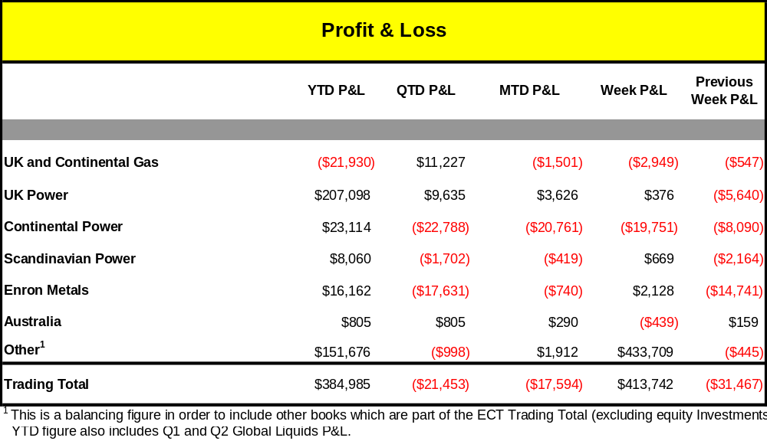

Summary

Over the week the UK and Continental Gas Book made a loss of $2.95m and the book exposure is now short .01 MMBTU compared to long 2.5 MMBT the previous week. The UK Gas Book reported P&L of $(2.84m) for the week. The short end of the UK Gas curve has seen higher prices this week essentially as the InterConnector failed to go into reverse flows as expected. This situation is likely to last until December as the November differential between Zeebrugge and NBP is flat. In this environment, prompt prices jumped as most players covered their short position. However the uncertainty about the InterConnector prevented active trading on the curve as traders adopted a wait and see attitude and as a result curve prices remained largely unchanged.

The Continental gas book reported profit of 271k for the week. The book’s net position remained 10bcf short over the last week, and the curve rose very slightly. Due to the balance of option positions vs. swaps, this translated as profit of 271k. Overall temperatures remained average throughout the week, with no discernable effect on the gas prices, though latterly temperatures have begun to dip in Southern Europe.
IUK remained in forward flow despite economic reverse flow - the rules on curtailment are set to be changed in the near future to enable economic flow. The market the price of gas at the hub has continued to decrease over the week, (down by between 1 and 2 p/therm in the prime trading area to Summer 01). This has been caused by lower demand than usual, and also warmer than usual seasonal weather. Over the course of this week, the Zeebrugge Hub Q401 contract closed at par with Zeebrugge, and there are still strong rumours that IUK will begin reverse flow in the coming week.

This week the UK power book made $376k and the book exposure remained relatively unchanged at short 49.0MMWh. This was due to almost entirely to a fall in the Intramonth curve (average £0.50), against a short position of 1.1TWh for the month of November.

Continental Power saw large losses durnig the week amounting to 19.8mm Usd, mailny in Delta Movement for the week. The weekly total delta loss from the German curves was (19 m Usd) against a net long position of 8.4 TWH.The German baseload curves decreased each day between 4.5 and .85 Usd until at least the end of 2001 and a couple of days until the end of 2003 with peak curves even decreasing by as much as 3.5 Usd. A key reason for the continual decrease is that the current weather conditions are milder than expected. This is causing the spot and forward prices to decrease. There are only a few counterparties trading in the market and they are mainly selling small volumes. Currently there is pressure on the forward markets and it's suggested that prices may continue to decline.

London Metals reported P&L of $2.1m for week ending 9th Nov. Aluminium contango curve at the front end became steeper, however the back end of the curve has gone from contango to backwardation on a long before short spread position (+$1.4m).Copper and Nickel curves have been relatively stable over the past week. Commission income of +$0.5m was earnt for the week. The uncertainty in the market results in the hedge funds and the others to buy/sell forward futures as the 3 mth price fluctuates.

The Scandinavian Book made 669k Usd for the week and the book exposure decreased by 0.6 MMWh to a long position of 5.0 MMWh compared to 8.5 MMWh the previous week. Majority of P&L is due to decreasing power prices. The price decrease came as a result of warmer weather than expected.

- Risk Analysis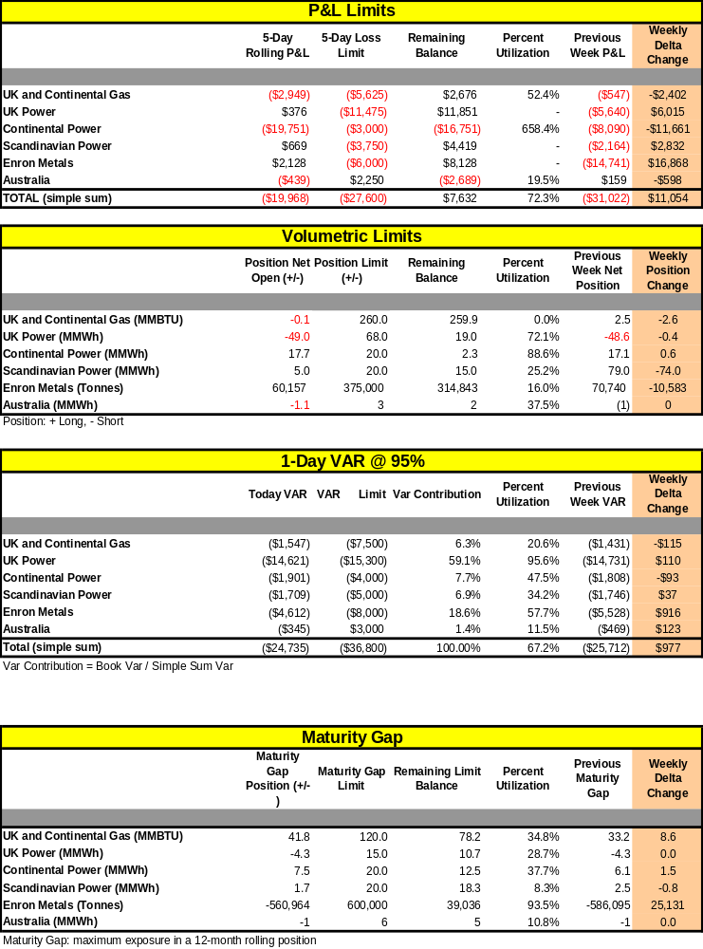

3) Curves and Positions

UK Power – Curves and curve shift

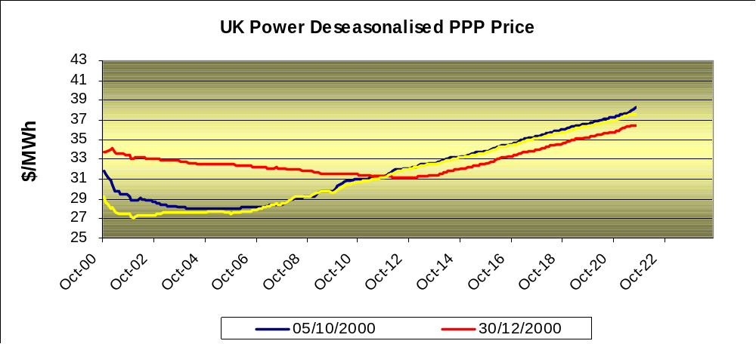

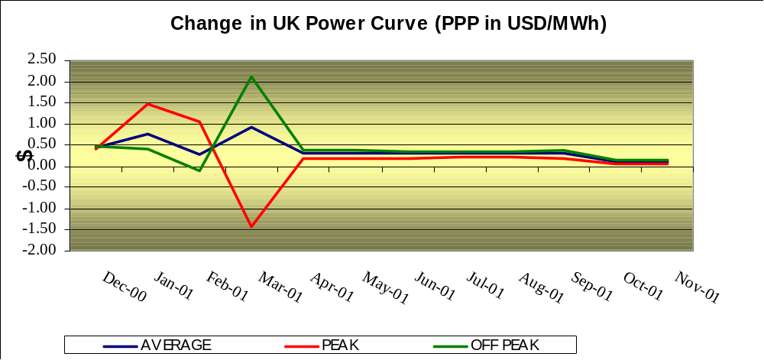

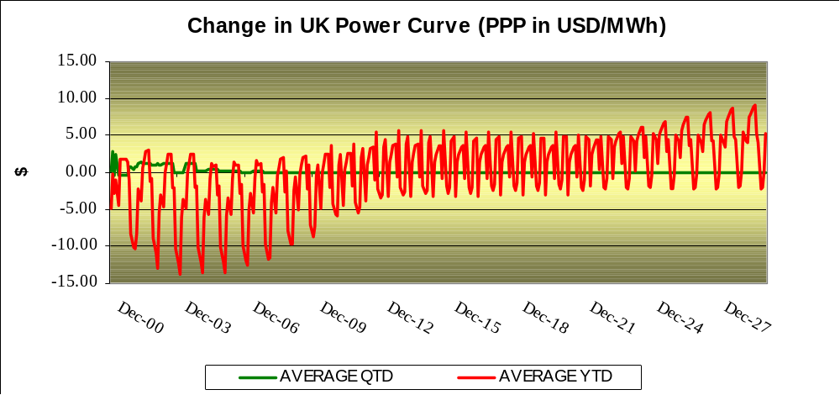

- Discounted volumes and changes in volumes

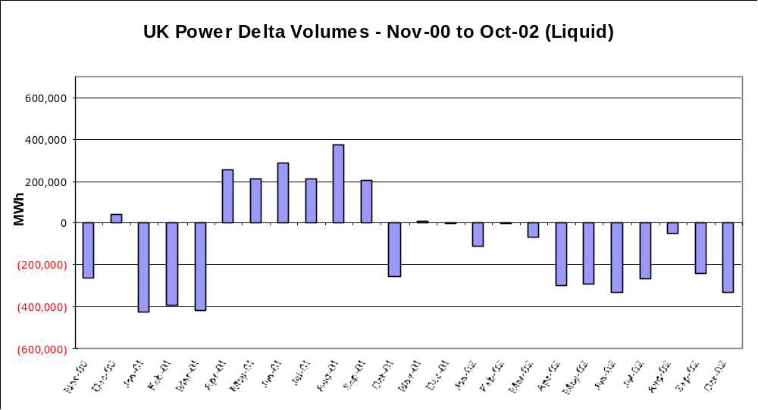

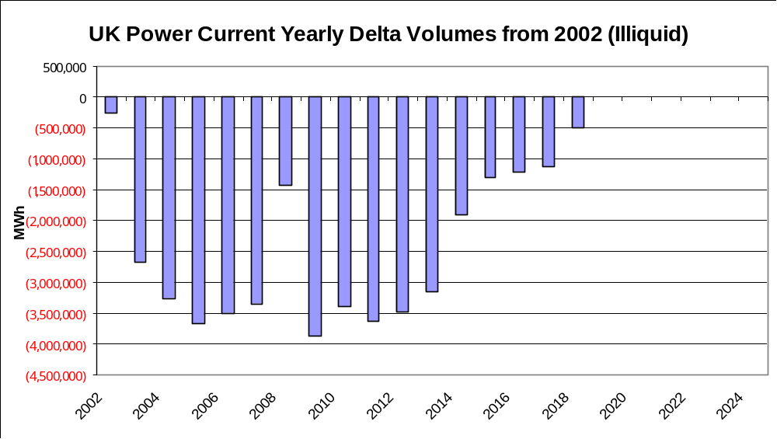

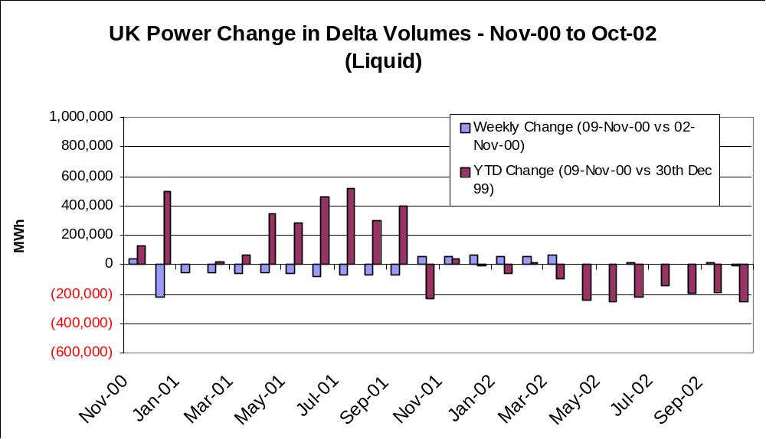

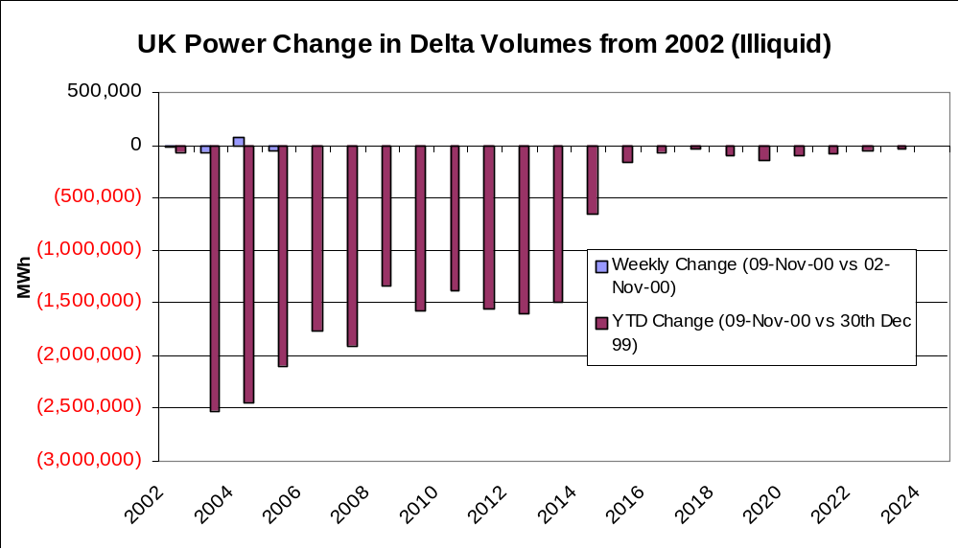

Continental Power – Curves and curve shift

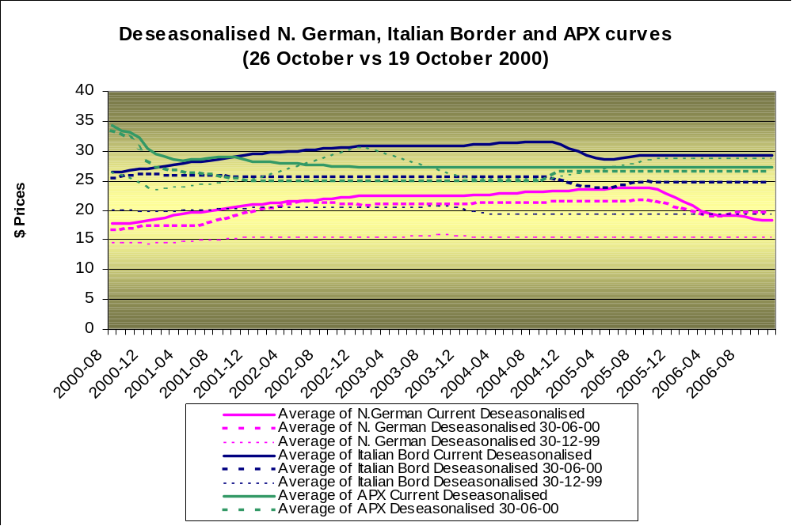

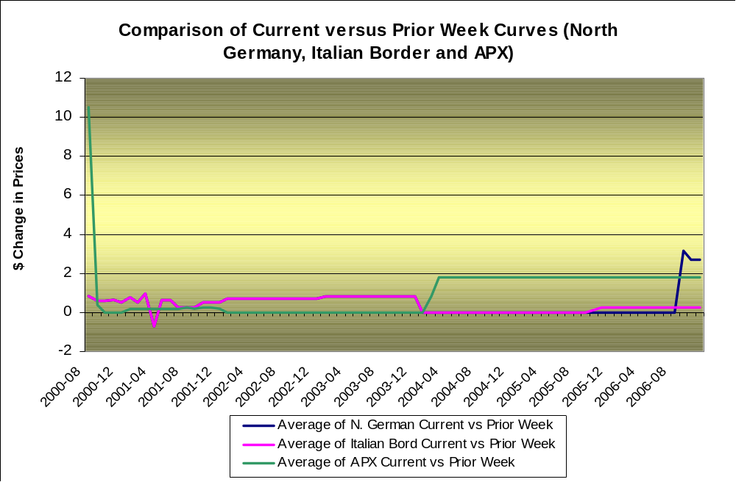

Discounted volumes and changes in volumes

Bilateral

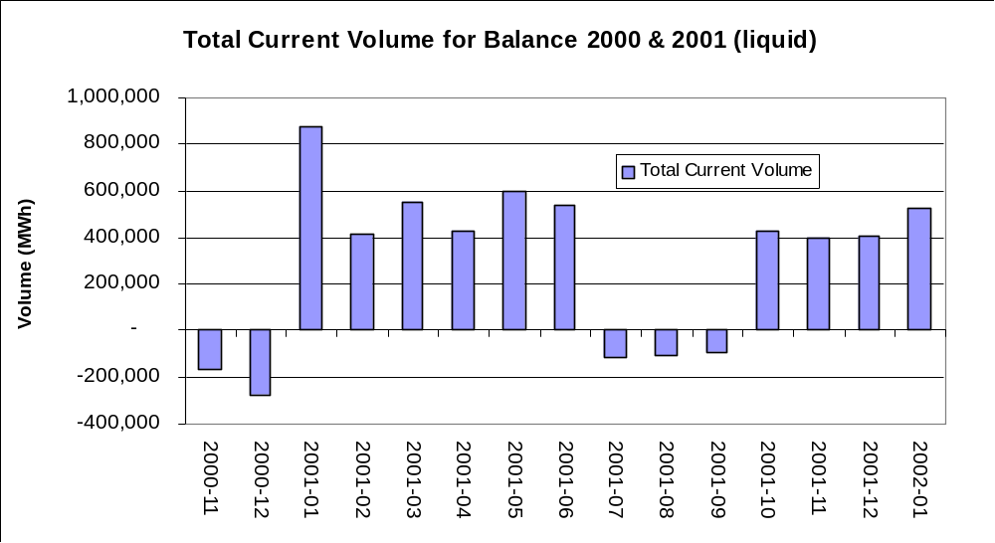

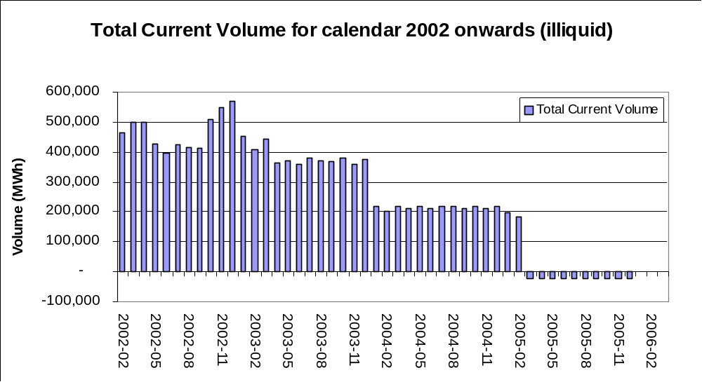

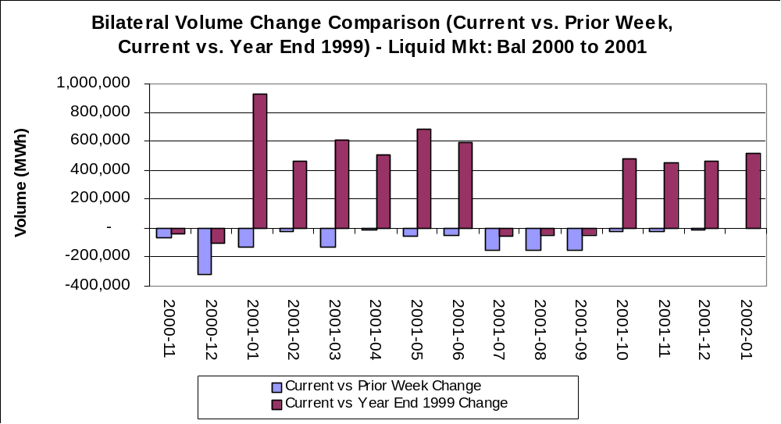

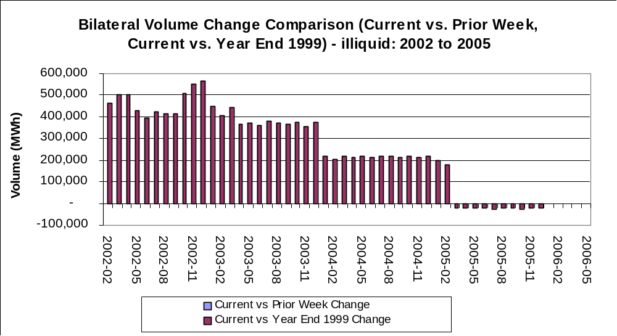

Pool

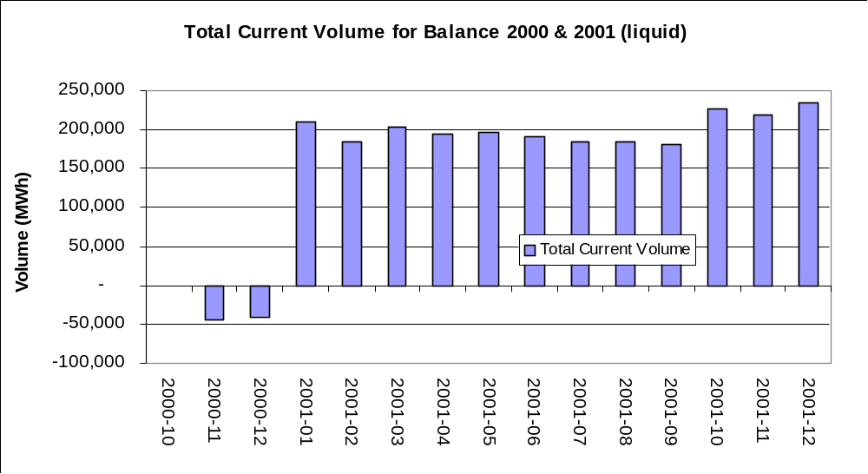

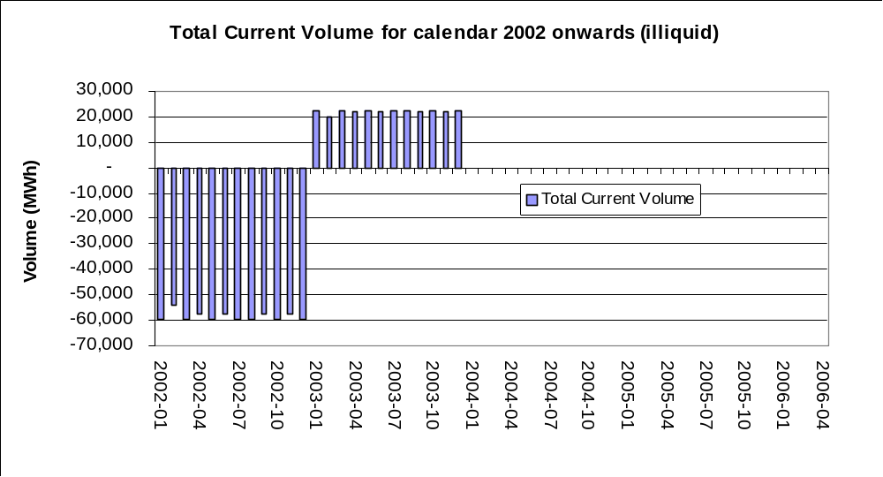

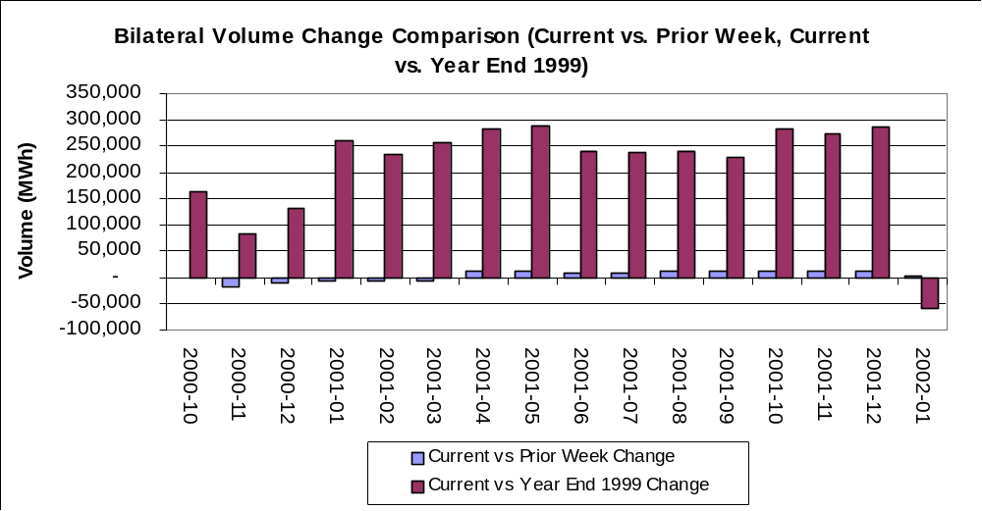

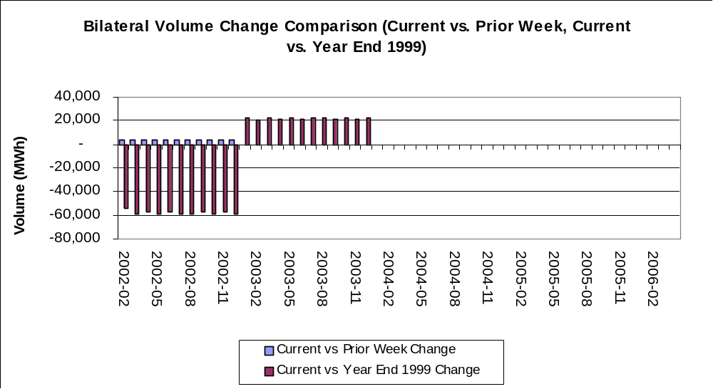

Nordic Power – Curves and curve shift

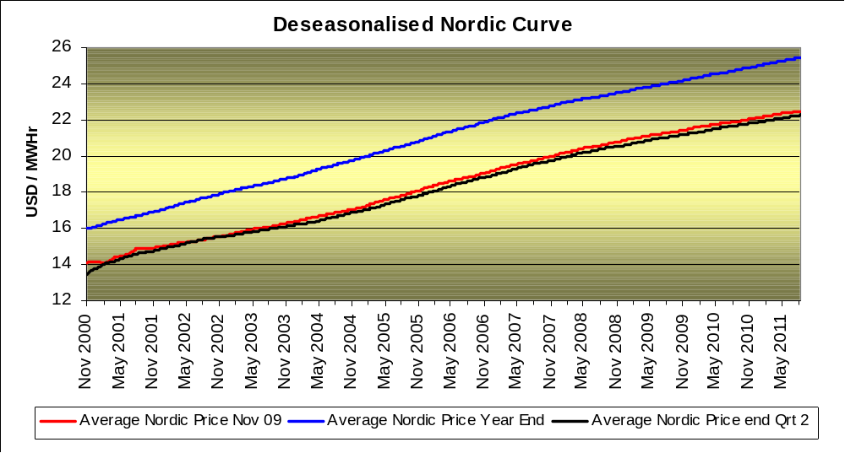

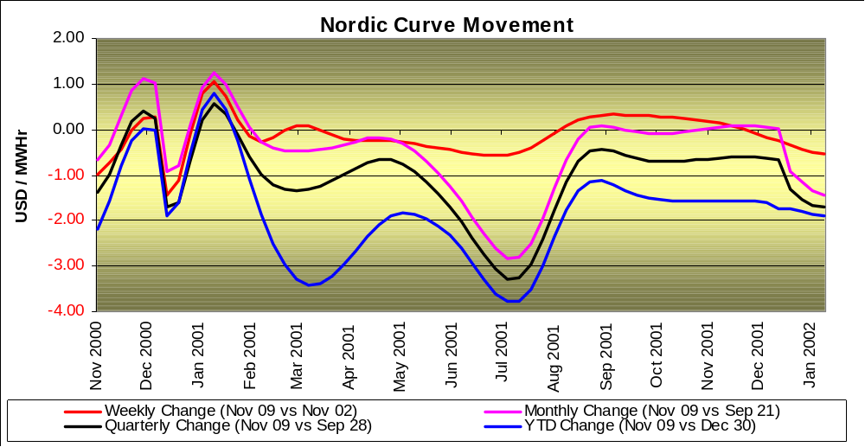

Discounted volumes and changes in volumes

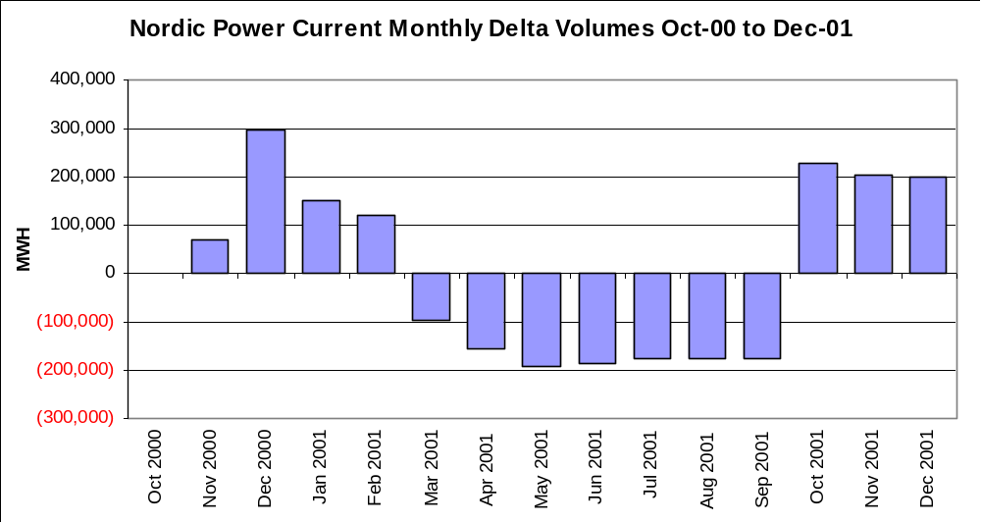

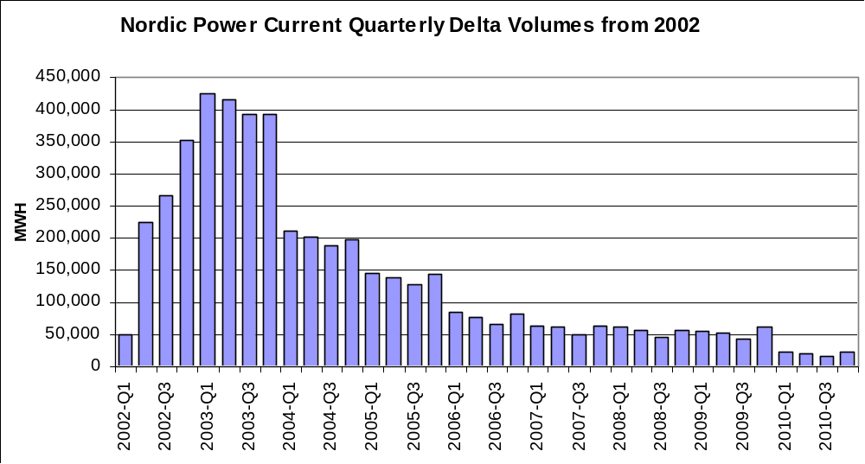

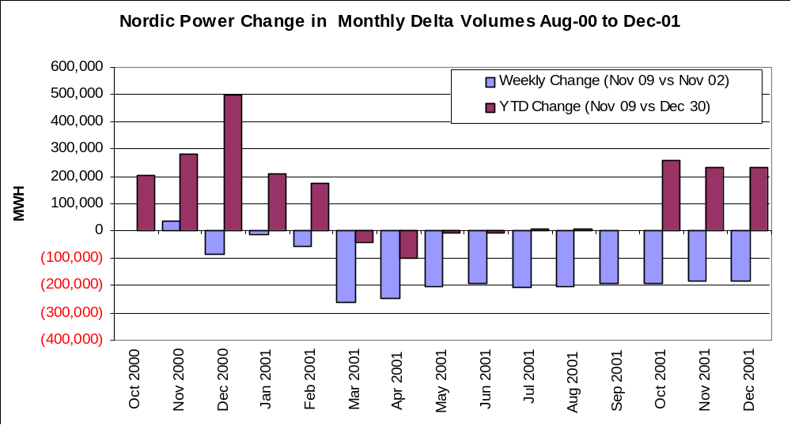

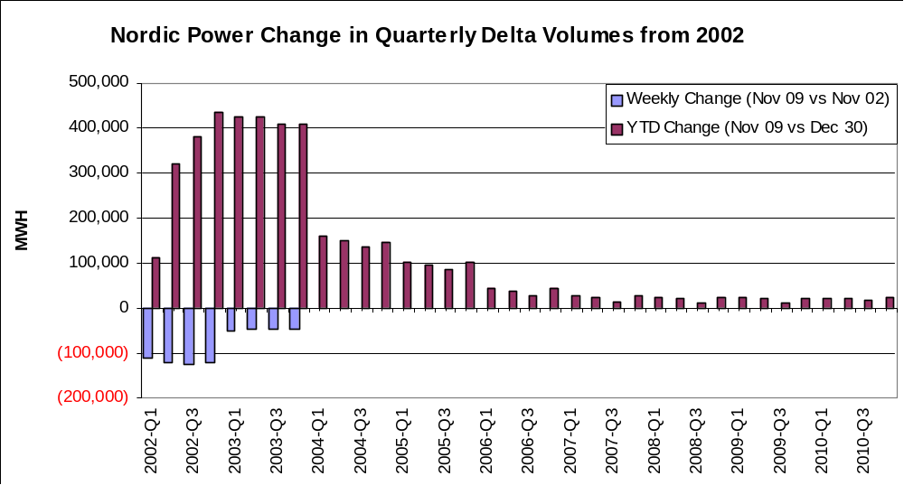

UK Gas – Curves and curve shift

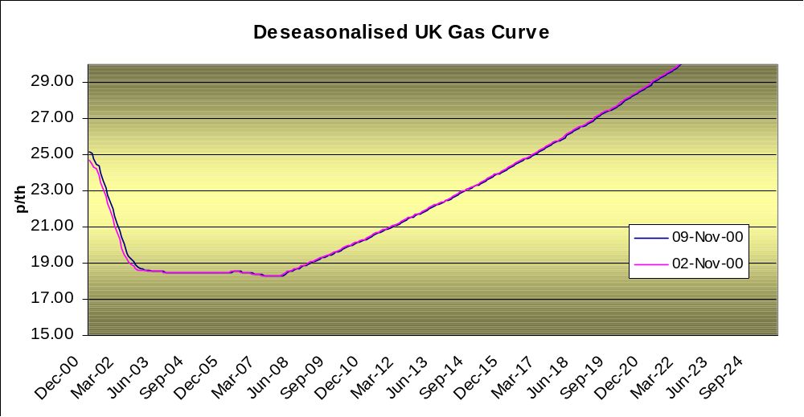

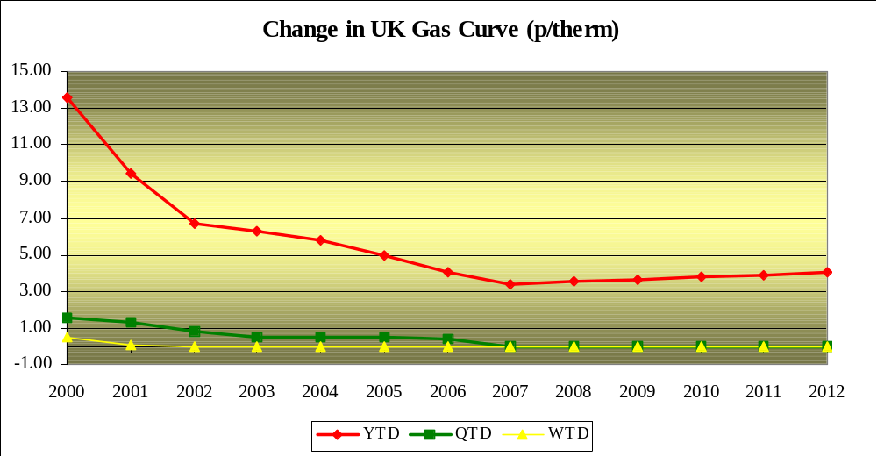

Discounted volumes and changes in volumes

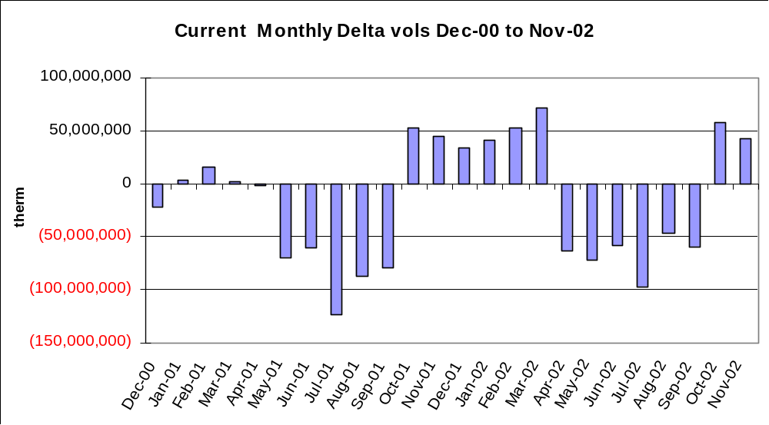

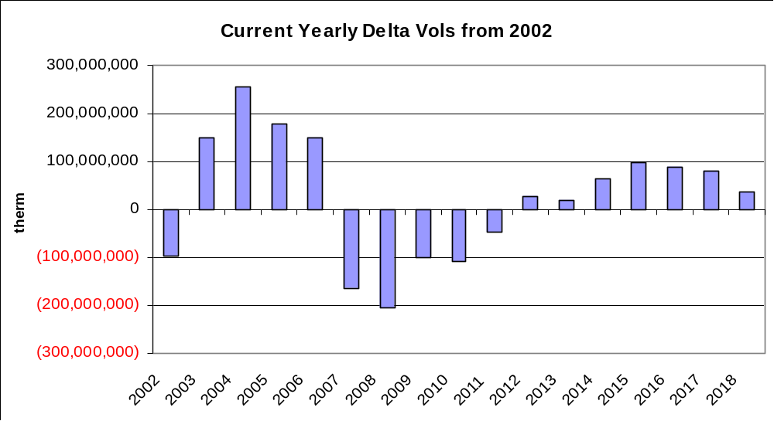

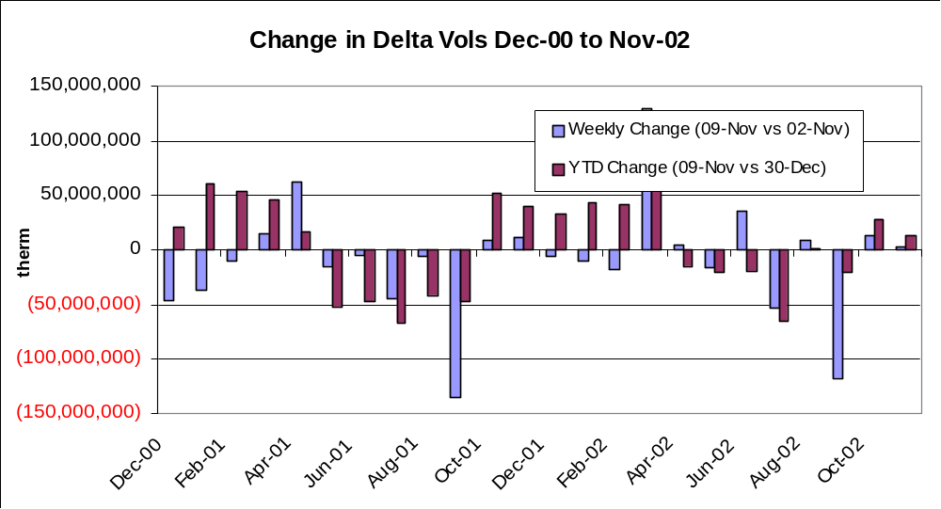

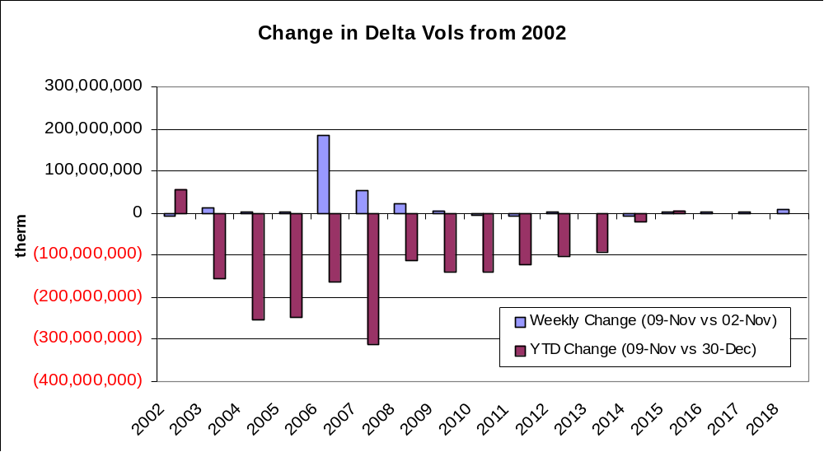

Continental Gas – Curves and curve shift

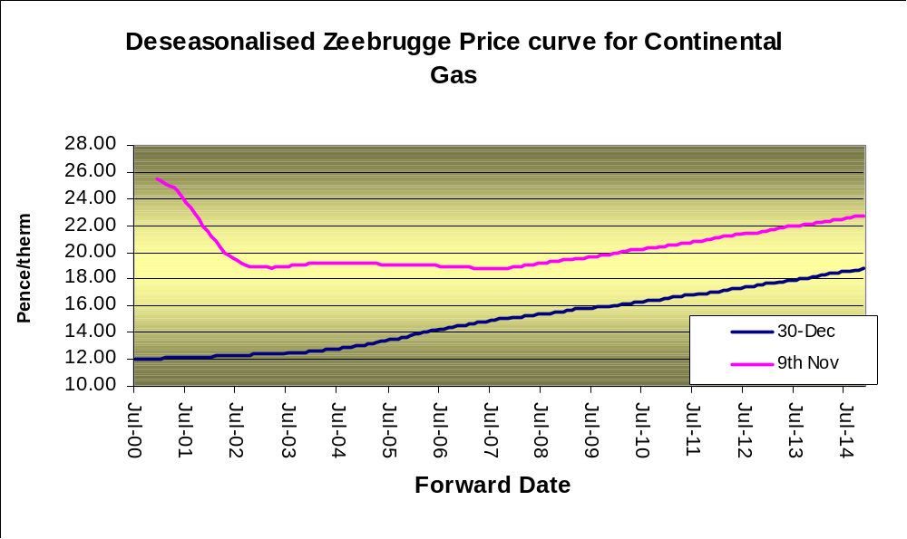

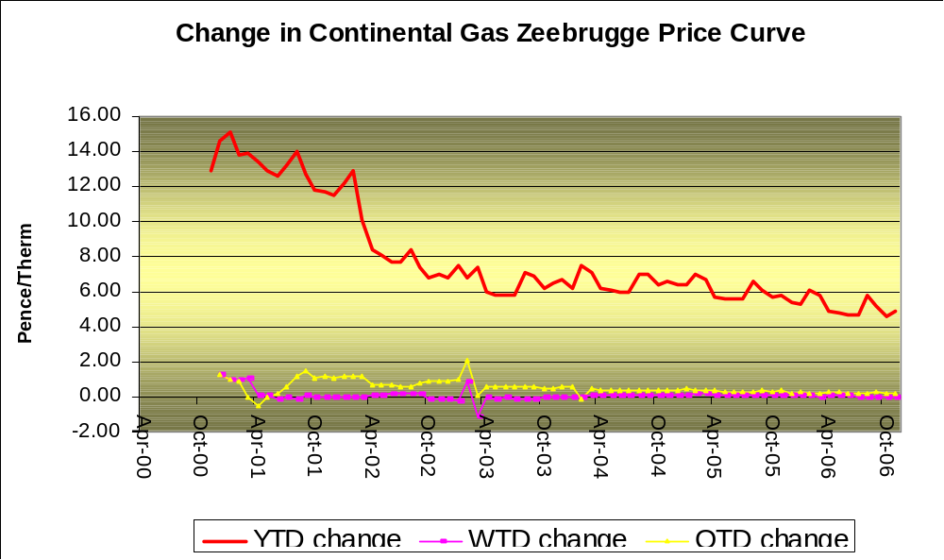

- Discounted volumes and changes in volumes

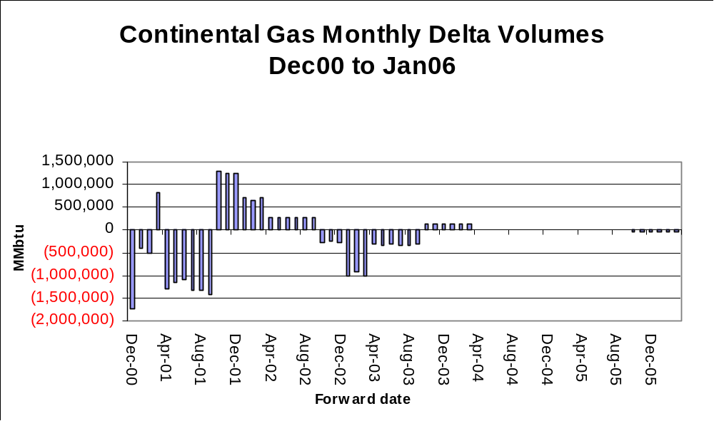

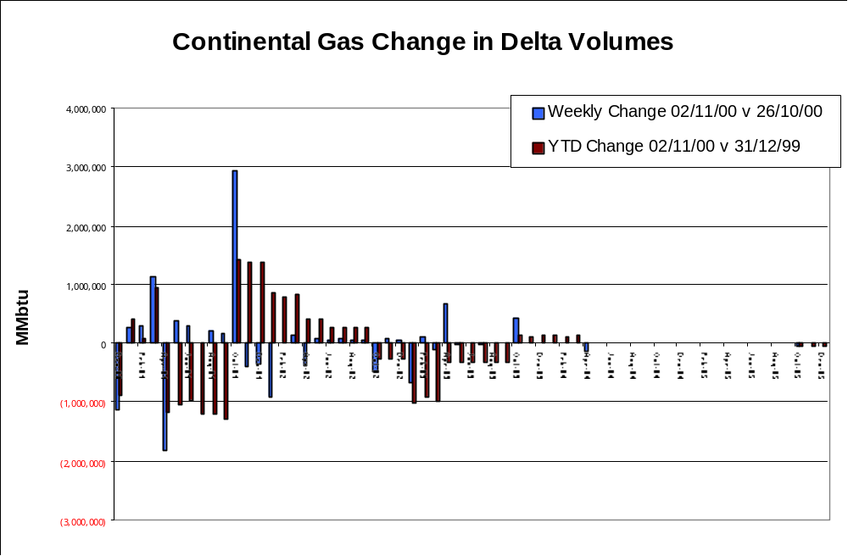

Spreads Book (Gamma Positions)

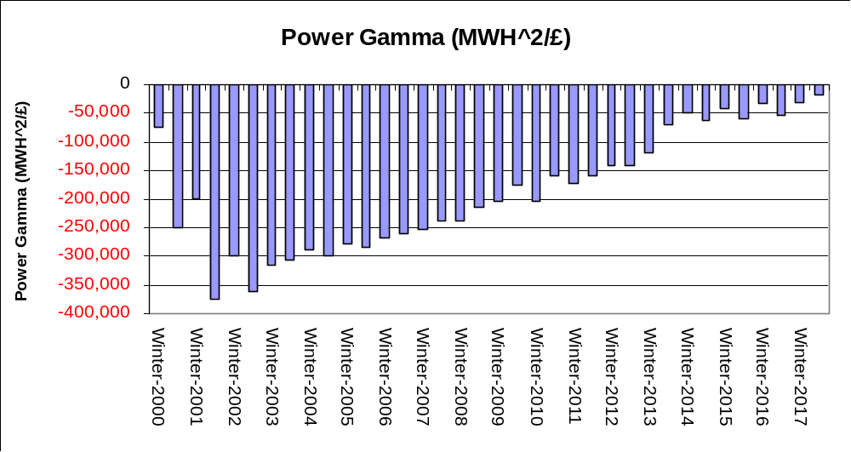

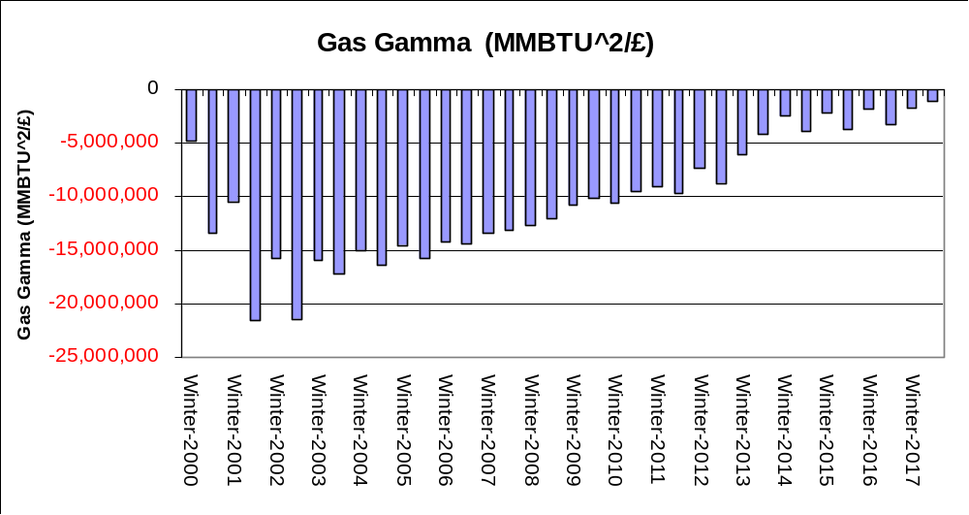

Spreads Book (Vega Positions)

